PRESS RELEASE

DUET Digital Twins Finalist at EU Conference of Ministers for Public Sector Transformation

Digital Flanders is a finalist for the EU Presidency ‘Tech for Government’ challenge showcasing how DUET Digital Twins collaboratively solve real-world policy challenges.

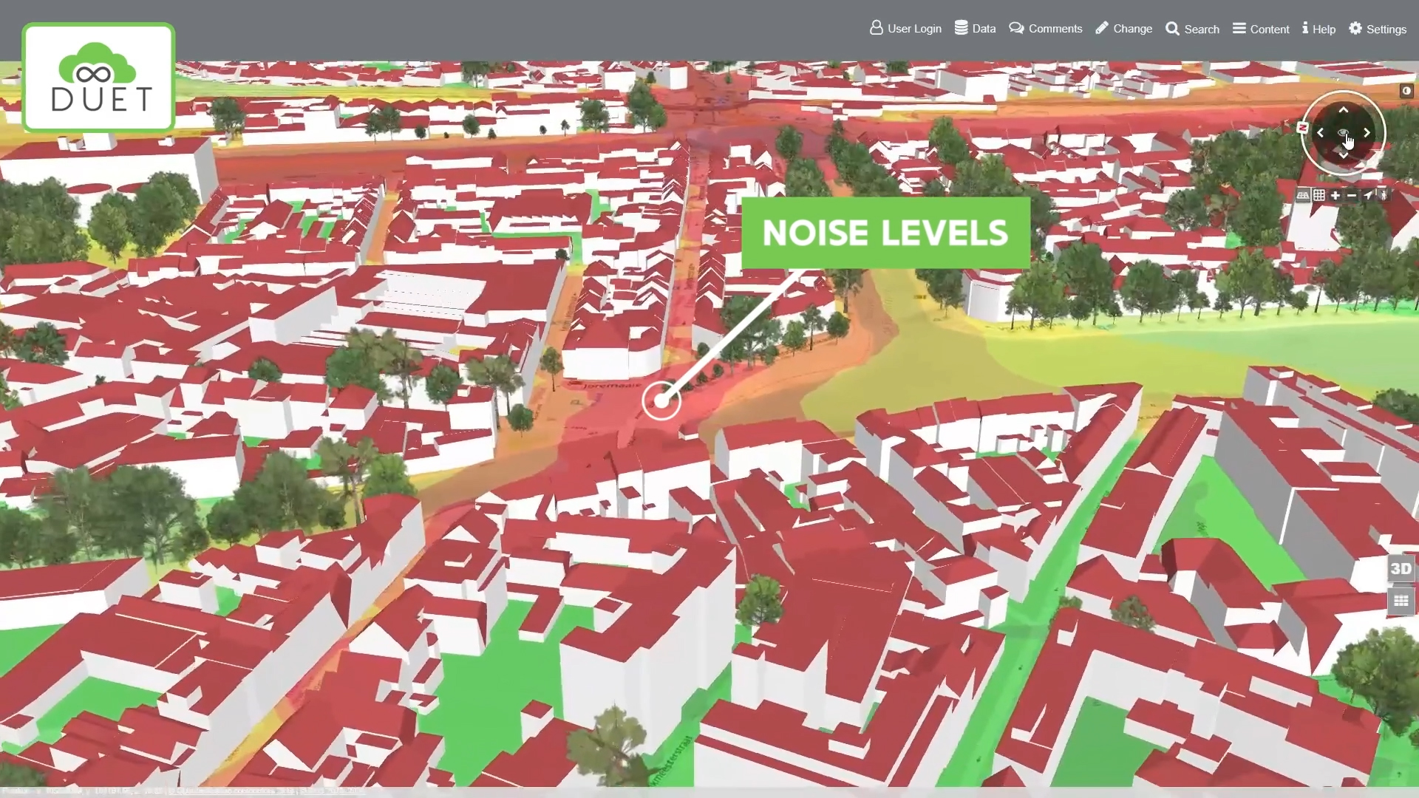
Thursday, March 17, 2022, Strasbourg, France — Digital Flanders joined delegations of Ministers in charge of public sector transformation this week as they travelled to the National Institute of Public Service in Strasbourg to adopt a new strategic framework for the European Public Administration Network (EUPAN).
Shortlisted as a finalist in the "Tech for Government Pitch" competition, sponsored by the French National Institute of Public Service in celebration of Frances take-over of the EU Presidency, Digital Flanders was given the opportunity to attend the meeting and introduce Ministers to their award-winning EU funded DUET Digital Twin initiative via a short film and pitch.
The conference was opened by Ms Maryvonne Le Brignone, Director of the National Institute for Public Service, along with European Commissioners Mr Johannes Hahn and Ms Elisa Ferreira, who stressed the importance of responsible technology adoption to address common challenges for 21st century public administrations.
Mr Lieven Raes and Mr Raf Buyle from Digital Flanders responded to the challenge by showcasing how DUET virtual 3D city replicas leverage both historic and real-time data sources to help public administration to make better evidence-based operational decisions and longer-term policy choices.
Using a real-life example of a potential bridge closure in Ghent, Ministers saw how various rerouting systems affected traffic volumes, noise and air quality in neighbouring streets. These contextual visuals, which anyone can easily understand, makes it easier for public administrations to collaborate on and communicate why specific decisions are made thereby strengthening democracy in the process.
“We couldn’t be prouder of being a finalist pitching to 27 EU Ministers” said Lieven Raes coordinator of DUET. “Listening to their needs and their visions makes us even more convinced that digital twin technology can be a cornerstone for creating high-quality, inclusive urban policy and public services. We believe that people are born problem solvers and given the right tools and support, all can understand and contribute to big policy ideas. Digital Twins help anyone regardless of background understand urban data and can help create local policies that are collaborative and sustainable”.
The DUET Digital Twin platform and video pitch can be accessed at www.digitalurbantwins,com

Background for Editors:
DUET (Digital Urban European Twins) has received funding from the EU Horizon 2020 research and innovation programme under grant agreement No.870697.

On the 10th of January 2022, 13 European teams - each with an innovative solution -were asked to present and defend their projects in front of a jury of European digital transformation experts. After the event the jury shortlisted 7 projects, including DUET, to proceed to the next stage.

For more information contact Susie Ruston McAleer, susie@21cconsultancy.com,
+44 7949252141

